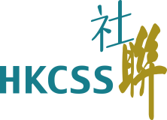

The Hong Kong Council of Social Service
HKCSS Most Impactful Small and Medium-sized Non-subvented NGO Award 2019

Enrollment Form

~Please submit Enrollment Form on or before 4th October 2019 5:00 pm~

To ： Membership Liaison and Service
The Hong Kong Council of Social Service
Fax ： 2864 2910
Email ： ProjectStar@hkcss.org.hk

Agency Name :
Name of Contact Person :
Phone no. : |  | Email :
Name of Agency Head : |  | Phone no. :
Signature :
 | (Agency Head)

Remarks：
- Please submit Agency Introduction Summary to the Council on or before 11 October 2019 5:00 pm.
Please visit the webpage of the Award Scheme (http://bit.ly/2019SmallNGOAward) and download the Agency Introduction Summary for use.

